Voice Order Agent – Requirements
Oct 5, 2026 · @jame · Version 0.9.0

Purpose and method
This document states what Voice Order Agent must do, worked out backwards from the running system at version 0.9.0 (tag v0.9.0, commit 1798944).
- Sources: the code (speech.py, recorder.py, order_agent.py, web_app.py, static/*.html, menu.json).
- Wording: each requirement says what the system shall do, not how it is built. Priority is Must (needed for classroom use) or Should (can come later).
- IDs and tracing: functional requirements are numbered FR-<area>-<n>, non-functional ones NFR-<n>. Each requirement names the acceptance test that checks it (R, C, W, V, K or E cases); “—” means no test covers it yet.
- Data flow diagrams: external entities are rectangles, processes are rounded boxes with a number, data stores are open-ended boxes marked D1–D3, and every arrow is labelled with the data it carries. Level 0 shows the whole system as one process; level 1 splits it into five processes; level 2 opens up process 3, the ordering conversation.

Users and stakeholders
Three kinds of people use the system, plus one outside service it depends on.
Who | Goal | Uses
Customer | Order food by typing or speaking, in Danish or English, and get a correct total | Customer page, terminal chat
Kitchen staff | See new orders at once and record when each is being prepared, ready and delivered | Kitchen page
Teacher and students | Show how speech becomes text, how an AI agent uses tools, and how text is stored as bytes | All parts, especially the hex view and the desktop recorder
Anthropic Claude API (external service) | Supplies the waiter's language understanding and replies | Called by the server

Context diagram (DFD level 0)
Seen from outside, Voice Order Agent is one process with three external entities: the customer, the kitchen staff and Anthropic's Claude API.
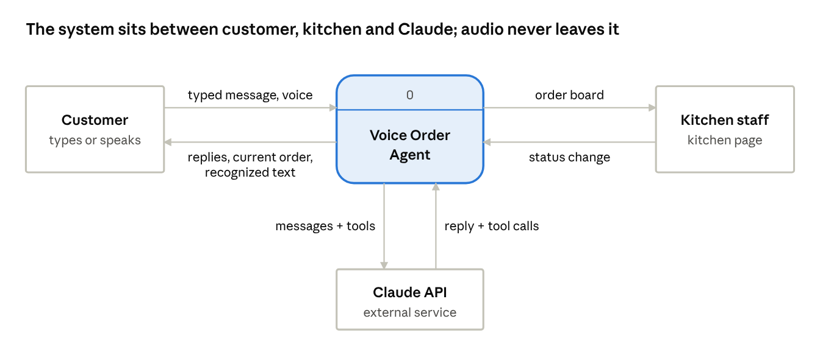
DFD level 0 · 1 process, 3 external entities, 6 data flows
Only text goes to Claude; the customer's voice is turned into text inside the system (FR-SPE-1, NFR-10).

Data flow diagram level 1
Inside, the system splits into five processes: record voice, recognize speech, hold the ordering conversation, save the order, and track its status. They share three data stores: D1 Menu, D2 Orders and D3 Conversations.
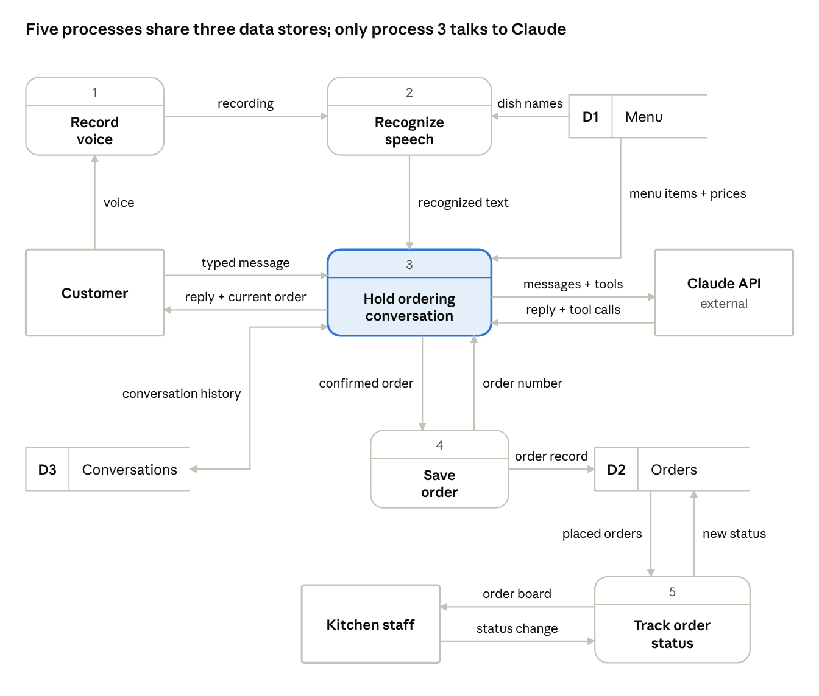
DFD level 1 · 5 processes, 3 data stores, 3 external entities
Processes 1–3 serve the customer and 5 serves the kitchen; the only link between the two sides is D2 Orders, written by process 4 and read by process 5.

Data flow diagram level 2: the ordering conversation
Process 3 has four steps: check the message (3.1), ask Claude (3.2), run the order tool Claude asks for (3.3), and send the reply (3.4). Steps 3.2 and 3.3 repeat until Claude answers in plain text.
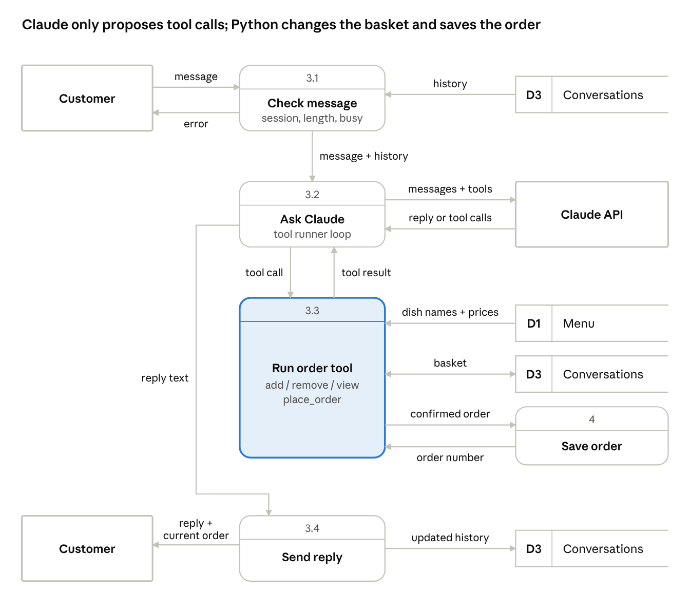
DFD level 2 of process 3 · 4 sub-processes
The Customer and D3 Conversations are drawn more than once to keep the lines short; each copy is the same entity or store. Because only 3.3 touches D1 and the basket, every price and total comes from Python (FR-ORD-4).

Functional requirements
Version 0.9.0 meets 53 functional requirements in seven areas; 50 are covered by an acceptance test (FR-ORD-5, FR-SPE-4 and FR-KIT-7 are not yet).

Ordering conversation (terminal and web)
ID | The system shall… | Priority | Test
FR-ORD-1 | hold a conversation with the customer and reply in the customer's language (Danish or English) | Must | C6, V4
FR-ORD-2 | add, remove and change the quantity of menu items, and refuse items that are not on the menu | Must | C2, C3, C4
FR-ORD-3 | store special requests (e.g. “no onions”) as notes on the item they belong to | Must | W4
FR-ORD-4 | calculate line totals and the order total from the menu prices, never from the AI's own figures | Must | C2, W2
FR-ORD-5 | match dish names tolerantly (English or Danish name, small misspellings) and suggest close matches when unsure | Should | —
FR-ORD-6 | answer questions about dishes and allergens from the menu only, and say so when the menu doesn't tell | Should | C5
FR-ORD-7 | read back the full order and total and get a clear confirmation and a name before placing it | Must | C7, W5
FR-ORD-8 | save a placed order with the next daily order number (starting at 1) and status Received, without ever overwriting another order | Must | C8, K2
FR-ORD-9 | stop changes to an order once it is placed, and refuse to place it twice | Must | W5
FR-ORD-10 | refuse to start without Anthropic credentials and explain how to add them | Must | C1
FR-ORD-11 | offer a terminal chat that can show the AI's tool calls (--debug) | Should | C2

Customer web page
ID | The system shall… | Priority | Test
FR-WEB-1 | show the greeting, the menu, the chat and the current order with total, updated after every reply | Must | W1, W2
FR-WEB-2 | add a dish's name to the message when the customer clicks it in the menu | Should | W3
FR-WEB-3 | start a fresh conversation and empty order when the customer clicks New order | Must | W6
FR-WEB-4 | keep a separate conversation and order for each browser tab | Should | W7
FR-WEB-5 | handle one message at a time per conversation and disable sending while waiting | Must | E4
FR-WEB-6 | forget conversations idle for 60 minutes and tell the customer when theirs has expired | Should | E3
FR-WEB-7 | be usable at phone width (about 400 px) without sideways scrolling | Should | W9
FR-WEB-8 | show a confirmation with the order number and lock the chat when the order is placed | Must | W5

Voice input (web)
ID | The system shall… | Priority | Test
FR-VOI-1 | record while the microphone button is held and send the recording when it is released | Must | V2
FR-VOI-2 | also allow click to start and click again to send | Should | V3
FR-VOI-3 | show the recognized text as the customer's message and send it to the waiter automatically | Must | V2
FR-VOI-4 | reject recordings shorter than 0.3 s or longer than 60 s with a message | Should | V5
FR-VOI-5 | explain when the microphone is blocked or missing, while typing keeps working | Should | V7
FR-VOI-6 | work from other devices on the network over HTTPS | Should | V8
FR-VOI-7 | discard a recording in progress when a new order is started | Should | V10

Speech recognition
ID | The system shall… | Priority | Test
FR-SPE-1 | recognize speech on the local computer, without sending audio to an outside service | Must | V2
FR-SPE-2 | use an NVIDIA GPU when one is available and fall back to the CPU otherwise or on a GPU error | Must | R6
FR-SPE-3 | ignore silence and noise instead of inventing text | Must | R7, V6
FR-SPE-4 | use the menu's dish names as vocabulary to recognize them better | Should | —
FR-SPE-5 | accept the recording formats browsers produce (WebM/Opus, Ogg, MP4, WAV) | Must | V2
FR-SPE-6 | let the operator choose the Whisper model and language when starting the web app | Should | V4

Kitchen page
ID | The system shall… | Priority | Test
FR-KIT-1 | list placed orders in the columns Received, Preparing, Ready and Delivered, each with a count | Must | K1
FR-KIT-2 | show a new order within 5 seconds, briefly highlighted | Must | K2
FR-KIT-3 | move an order one step forward and record the time of each step | Must | K3, K8
FR-KIT-4 | move an order one step back to undo a mistake, and refuse jumps of more than one step | Must | K4
FR-KIT-5 | show each order's number, name, dishes with notes, total and waiting time | Must | K2
FR-KIT-6 | highlight orders that have waited more than 15 minutes and are not delivered | Should | K5
FR-KIT-7 | list waiting orders oldest first and show only today's delivered orders | Should | —
FR-KIT-8 | keep every order's status when the server restarts | Must | K6
FR-KIT-9 | work on several screens at once | Should | K7
FR-KIT-10 | tell staff when the server can't be reached and recover by itself | Must | E1

Desktop recorder
ID | The system shall… | Priority | Test
FR-REC-1 | record from the microphone at 16 kHz mono and show the elapsed time | Must | R1
FR-REC-2 | play back the last recording | Must | R1
FR-REC-3 | save the recording as a 16-bit WAV file | Should | R2
FR-REC-4 | transcribe the recording afterwards and show the detected language | Must | R3
FR-REC-5 | transcribe live while recording: provisional text in grey, final text in black after a pause of about 1 s | Must | R4
FR-REC-6 | let the user choose model, language and vocabulary, locked while they are in use | Should | R5
FR-REC-7 | show whether the GPU or the CPU is used | Should | R6

Teaching aids
ID | The system shall… | Priority | Test
FR-TEA-1 | on request, show every chat message as characters with their UTF-8 bytes in hex (0x..), colored by byte count, with a live preview while typing | Should | W8
FR-TEA-2 | show a character's Unicode code point and binary bytes on hover, and remember the setting | Should | W8
FR-TEA-3 | for spoken messages, show the size of the sound next to the size of the text | Should | V9
FR-TEA-4 | show the same hex view in the terminal chat (--hex) | Should | C9

Data dictionary
The diagrams use three data stores and the flows below; + means “and”, { } means “repeated”, and ( ) means “optional”.
Data stores
Store | Kept in | Contents | Kept for
D1 Menu | menu.json | restaurant + currency + {item id + name + Danish name + category + price + description + {allergen} + vegetarian} | Until edited by hand
D2 Orders | orders/*.json | order number + customer name + time placed + {line: item id + name + quantity + (notes) + price + line total} + total + currency + status + {status + time} | Permanently
D3 Conversations | Server memory | session id + {message} + basket + last used | 60 minutes idle, or until restart
Data flows
Flow | From → To | Contents
Typed message | Customer → 3 | text (max 1,000 characters)
Voice | Customer → 1 | spoken words via the microphone
Recording | 1 → 2 | compressed audio (WebM/Opus or similar, max 10 MB, 0.3–60 s)
Dish names | D1 → 2 | English + Danish names of all items, as vocabulary
Recognized text | 2 → 3 (also shown to the customer) | text + language + sound size (seconds, samples, bytes)
Menu items and prices | D1 → 3 | the whole menu
Conversation history | D3 ↔ 3 | {message} including tool calls and tool results
Messages and tools | 3 → Claude API | system prompt with menu + {message} + tool definitions
Reply and tool calls | Claude API → 3 | reply text, or {tool call: name + arguments}
Reply and current order | 3 → Customer | reply text + {line} + total + (order number) + done
Confirmed order | 3 → 4 | basket + customer name
Order record | 4 → D2 | a new order with status Received
Order number | 4 → 3 | the next daily number
Placed orders | D2 → 5 | {order record}
Order board | 5 → Kitchen staff | orders grouped by status + waiting time
Status change | Kitchen staff → 5 | order id + new status
New status | 5 → D2 | status + time of change
Flows inside process 3 (level 2)
Flow | From → To | Contents
Message | Customer → 3.1 | typed or recognized text + session id
Error | 3.1 → Customer | short message: empty text, expired conversation, order already placed, or reply still pending
History | D3 → 3.1 | the session's {message}
Message + history | 3.1 → 3.2 | {message} + the new message
Tool call | 3.2 → 3.3 | tool name + arguments, e.g. add_item(item, quantity, notes)
Tool result | 3.3 → 3.2 | the updated order as text, or an error such as “not on the menu”
Basket | D3 ↔ 3.3 | {line} + total
Reply text | 3.2 → 3.4 | Claude's final answer for this turn
Updated history | 3.4 → D3 | every message of the turn, including tool calls and results

Non-functional requirements
The figures below are what version 0.9.0 achieves on the development PC (NVIDIA RTX A1000); they are the targets for later versions.
ID | Area | Requirement | Priority | Test
NFR-1 | Performance | A 5-second spoken message shall be recognized within 2 s on a PC with an NVIDIA GPU (measured: about 1 s) | Should | V2
NFR-2 | Performance | The speech model shall be loaded when the server starts, so the first customer doesn't wait for it | Should | —
NFR-3 | Performance | The kitchen page shall show changes within 5 s | Must | K2, K7
NFR-4 | Usability | The waiter's replies shall be short (one to three sentences) and free of formatting, so they can later be read aloud | Should | C2
NFR-5 | Usability | Every error shall be shown to the user as a short, plain message, never as a technical error page | Must | E1–E3
NFR-6 | Security | The Anthropic API key shall stay on the server and never reach a browser | Must | E8
NFR-7 | Security | Text from users and the AI shall be shown as plain text, never run as HTML or script | Must | E6
NFR-8 | Security | Requests shall only reach order files, never other files on the server | Must | E7
NFR-9 | Security | Messages shall be limited to 1,000 characters and uploads to 10 MB | Should | E5
NFR-10 | Privacy | Recordings shall not be stored; audio shall not leave the server PC | Must | —
NFR-11 | Privacy | Order files with customer names shall not be published (excluded from Git) | Must | E8
NFR-12 | Reliability | A failed chat turn shall be rolled back so the customer can repeat it without duplicate items | Must | E2
NFR-13 | Reliability | Order files shall never be half-written or overwritten | Must | K6
NFR-14 | Portability | The system shall run on Windows 11 with Python 3.10 or newer, with or without an NVIDIA GPU | Must | R6
NFR-15 | Portability | The pages shall work in current Chrome and Edge on PC and phone | Must | W9, V8

Constraints, assumptions and open questions
Constraints
- The waiter needs internet and a paid Anthropic API key; speech recognition works offline.
- Browsers allow the microphone only on localhost or over HTTPS.
- Whisper processes at most 30 seconds of audio at a time.
- Flask's built-in server is used, so the system is for a classroom or local network, not the open internet.
Assumptions
- One restaurant with one menu, prices in DKK, and no payment.
- Customers speak Danish or English.
- The server PC's clock is correct (order numbers and waiting times depend on it).
- Only one server process places orders at a time; the terminal chat and the web app are not used to place orders at the same moment.
Open questions
- ☐ Should the kitchen page require a PIN or login?
- ☐ Should customers see their order's status (preparing, ready) after placing it?
- ☐ Should the waiter speak its replies aloud?
- ☐ Should ordering be possible hands-free (send on pause) instead of push-to-talk?
- ☐ How long should order files be kept, given they contain customer names?
- ☐ Should the three untested requirements (FR-ORD-5, FR-SPE-4, FR-KIT-7) get acceptance tests?

